**Final Year B. Tech., Sem VII 2022-23**

**Cryptography And Network Security**

**PRN/ Roll No: 2020BTECS00206**

**Full Name: SAYALI YOGESH DESAI**

**Batch: B4**

**Assignment No. 9**

1. **Aim:**

Implementation of Prime Factorization for large numbers.

1. **Theory:**

RSA Laboratories states that:

for each RSA number n, there exists prime numbers p and q such that n = p × q.

The problem is to find these two primes, given only n.

The RSA Factoring Challenge was a challenge put forward by RSA Laboratories to encourage research into computational number theory and the practical difficulty of factoring large integers and cracking RSA keys used in cryptography. They published a list of semiprimes (numbers with exactly two prime factors) known as the RSA numbers, with a cash prize for the successful factorization of some of them.

1. **Code:**

#include <bits/stdc++.h>

using namespace std;

typedef long long ll;

typedef vector<long long> vl;

#define pll pair<ll, ll>

#define vpll vector<pll>

#define vb vector<bool>

#define PB push_back

#define MP make_pair

#define ln "\n"

#define forn(i,e) for(ll i=0; i<e; i++

#define forsn(i,s,e) for(ll i=s; i<e; i++)

#define rforn(i,e) for(ll i=e; i>=0; i--)

#define rforsn(i,s,e) for(ll i=s; i>=e; i--)

#define vasort(v) sort(v.begin(), v.end())

#define vdsort(v) sort(v.begin(), v.end(),greater<ll>())

#define arrasort(arr,n) sort(arr,arr+n)

#define arrdsort(arr,n) sort(arr,arr+n,greater<ll>())

#define F first

#define S second

#define out1(x1) cout << x1 << ln

#define out2(x1,x2) cout << x1 << " " << x2 << ln

#define out3(x1,x2,x3) cout << x1 << " " << x2 << " " << x3 << ln

#define out4(x1,x2,x3,x4) cout << x1 << " " << x2 << " " << x3 << " " << x4 << ln

#define out5(x1,x2,x3,x4,x5) cout << x1 << " " << x2 << " " << x3 << " " << x4 << " " << x5 << ln

#define out6(x1,x2,x3,x4,x5,x6) cout << x1 << " " << x2 << " " << x3 << " " << x4 << " " << x5 << " " << x6 << ln

#define in1(x1) cin >> x1

#define in2(x1,x2) cin >> x1 >> x2

#define in3(x1,x2,x3) cin >> x1 >> x2 >> x3

#define in4(x1,x2,x3,x4) cin >> x1 >> x2 >> x3 >> x4

#define in5(x1,x2,x3,x4,x5) cin >> x1 >> x2 >> x3 >> x4 >> x5

#define in6(x1,x2,x3,x4,x5,x6) cin >> x1 >> x2 >> x3 >> x4 >> x5 >> x6

#define mz(a,val) memset(a,val,sizeof(a))

#define arrin(a,n) forn(i,n) cin >> a[i];

#define arrout(a,n) forn(i,n) {cout << a[i] << " ";} cout << ln;

#define fio ios_base::sync_with_stdio(false);cin.tie(NULL);cout.tie(NULL)

#define mod 1000000007

void file()

{

#ifndef ONLINE_JUDGE

freopen("input.txt", "r", stdin);

freopen("output.txt", "w", stdout);

#endif

}

string longDivision(string number, ll divisor)

{

// As result can be very large store it in string

string ans;

// Find prefix of number that is larger

// than divisor.

ll idx = 0;

ll temp = number[idx] - '0';

while (temp < divisor)

temp = temp * 10 + (number[++idx] - '0');

// Repeatedly divide divisor with temp. After

// every division, update temp to include one

// more digit.

while (number.size() > idx) {

// Store result in answer i.e. temp / divisor

ans += (temp / divisor) + '0';

// Take next digit of number

temp = (temp % divisor) * 10 + number[++idx] - '0';

}

// If divisor is greater than number

if (ans.length() == 0)

return "0";

// else return ans

return ans;

}

string multiply(string num1, string num2)

{

int len1 = num1.size();

int len2 = num2.size();

if (len1 == 0 || len2 == 0)

return "0";

// will keep the result number in vector

// in reverse order

vector<int> result(len1 + len2, 0);

// Below two indexes are used to find positions

// in result.

int i_n1 = 0;

int i_n2 = 0;

// Go from right to left in num1

for (int i = len1 - 1; i >= 0; i--)

{

int carry = 0;

int n1 = num1[i] - '0';

// To shift position to left after every

// multiplication of a digit in num2

i_n2 = 0;

// Go from right to left in num2

for (int j = len2 - 1; j >= 0; j--)

{

// Take current digit of second number

int n2 = num2[j] - '0';

// Multiply with current digit of first number

// and add result to previously stored result

// at current position.

int sum = n1 * n2 + result[i_n1 + i_n2] + carry;

// Carry for next iteration

carry = sum / 10;

// Store result

result[i_n1 + i_n2] = sum % 10;

i_n2++;

}

// store carry in next cell

if (carry > 0)

result[i_n1 + i_n2] += carry;

// To shift position to left after every

// multiplication of a digit in num1.

i_n1++;

}

// ignore '0's from the right

int i = result.size() - 1;

while (i >= 0 && result[i] == 0)

i--;

// If all were '0's - means either both or

// one of num1 or num2 were '0'

if (i == -1)

return "0";

// generate the result string

string s = "";

while (i >= 0)

s += std::to_string(result[i--]);

return s;

}

ll isPrime(ll n)

{

// Corner case

if (n <= 1)

return 0;

// Check from 2 to square root of n

for (ll i = 2; i <= sqrt(n); i++)

if (n % i == 0)

return 0;

return 1;

}

int main()

{

ll t = 1;

//cin >> t;

while (t--)

{

string s;

cout<<"\n Enter the number : ";

cin >> s;

ll till = 100000;

for (ll i = 1; i < till; i++)

{

//cout << i << endl;

if (isPrime(i) == 0)

{

continue;

}

//cout << i << endl;

ll first = i;

string fs = to_string(first);

string x = longDivision(s, i);

if (multiply(fs, x) != s)

continue;

cout << first << endl;

cout << x << endl;

cout << endl;

break;

}

}

return 0;

}

1. **Output:**

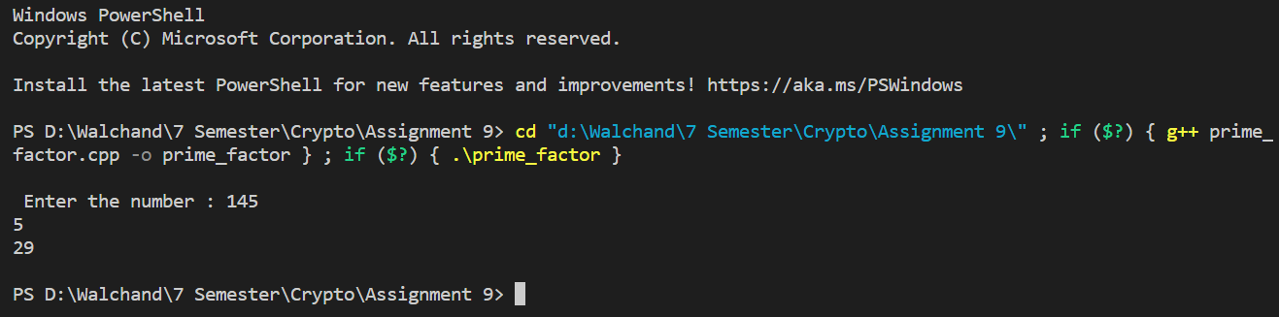

1. **Conclusion:**

Successfully implemented RSA Prime Factorization for large numbers.